 **19 Dec 2014** **The Weekly Bulletin of Rotary Club of Kathmandu Mid-Town** **bc-24/12.014**

|  |
| --- |
|  |

District: 3292 Web:www.rotarymidtown.org.np Club Id: 26776

**DECEMBER IS THE FAMILY MONTH**

**Rotarians, clubs, and districts worldwide are encouraged to demonstrate their**

**commitment to family and community through projects, activities, and events in**

**celebration of Family Month each December.**

Club’s Weekly Meeting # 1258 on Friday, 12 December :

Extracts of the Meeting Minutes are given below:

“1. Meeting No.1258 called to order

“7. A few remarks by the President

“8. Short talk by Dr Milan Maharjan, ENT specialist. Dr Maharjan explained that in more than 50 % of the cases deafness

is preventable. She is a qualified ENT surgeon who has recently given up her private practice to dedicate herself to full

time social work. She has visited most of the public schools in Lalitpur District and has screened over 8000 cases. With

the good help of a local hospital who provides its operating theatre for a very reasonable fee and with the help

foreign doctors she has been able to help hundreds of children For more information see Ear Care Nepal at

www.earcarenepal.org.

“9. Information sharing:

> Mid-Town trip to Mugu – Rara ANM Project - set to leave Dec. 12 . 14 Mid-Towners. have signed up. We wish them a

good journey and ask them to make sure that we get some good photos and please help us to collect a few really

good 'success stories'

> If you have photos from past meetings please share with Sec Isa (for the DG's visit report) and with PP Lekha for the

Governor's Monthly Newsletter – none have yet been received!

> Rotary Peace Conference. Leaving Ktm-Lumbini at 5 AM on 07 Feb and returning Lumbini to Ktm at 10 AM on 09

Feb. Rtns can contact PP William Ma. Fares between Rs 3500 to Rs 4000 for the return journey.

> See info on 'Rickshaw Race" tomorrow – everyone is invited.

> PP William reported on the Saturday morning walkers' club. Great fun to be had. Pls contact PP Komal for the date

and place of the next walk.

> Please note: 2 Jan - no meeting.

“10. Statistics of the meeting: Members present: 27”.

# Weekly Meetings and Programs :

|  |  |  |
| --- | --- | --- |
| Date | Program/Speaker | Topic of Presentation |
| 19 December | Tomoo Hozumi | UN/UNICEF |
|  |  |  |
|  |  |  |
|  |  |  |

**Committee Chairs’ Column:** *(This column is for use by chairpersons of 5 permanent committees: Club Administration, Membership, Public Relations, Service Projects, and the Rotary Foundation)*

**The Rotary Foundation Seminar**

The District Rotary Foundation Seminar is going to be held on 27 December 2014.

ARRFC Deepak Talwar will be the keynote speaker on that day.

Date: 27 December 2014; Time: 13:00 hrs (1:00 PM)

Venue: Hotel Platinum, near Hotel Soaltee Crown Plaza, Soaltee-mode, Kathmandu

Registration fee: Rs 1,500

Please contact PDG Basu Dev Golyan, Chair, District Rotary Foundation Committee, or

at the Rotary District Office (email: [rotary@ntc.net.np](mailto:rotary@ntc.net.np)  Tel: 016224166/98373897)

**Updating Club Members Details:**

A request letter from PDG Tirtha Man Sakya,

Officer on Special Duty for Membership Development & Retention:

“I would like to request you to kindly update the details of the member/s you have recently inducted/

added in your club through your member access in Rotary International database by **31 Dec 2014**.  So that the member sponsoring the new member/s will get recognition pin from Rotary International (Blue/Red/Golden/Platinum backer pin of membership recognition gallery).

If you have any queries, do let me know.”  - PDG Tirtha Man Sakya

**South Asia Conference on Peace: 6-9 Feb 2015**

RI District 3292 - Nepal/Bhutan is organising 'Rotary South Asia Conference on Peace' during 6-9 February 2015

in Lumbini, the birth place of Lord Gautam Buddha, the ***Light of Asia***.

The Ministry of Peace and Reconstruction, the Ministry of Culture, Tourism and Civil Aviation and

the Ministry of Cooperatives and Poverty Alleviation are co-organizing this event.

Selected themes for the Conference are:

"Fountain of Peace",

"Peace and Conflict Prevention and Resolution",

"Role of UN in Peace Building in South Asia",

"Peace and Poverty Alleviation in South Asia",

"Peace and Tourism Development in South Asia",

"Youth as Builders of Peace," and

"Role of SAARC on Peace in South Asia"

**Members’ Corner:** *(This column is for Club members to express anything they would like in matter of Club activities, Club administration, Club issues or on Breakfast Chatter, or on anything else that would be of interest to fellow members.)*

Travel and Tourism

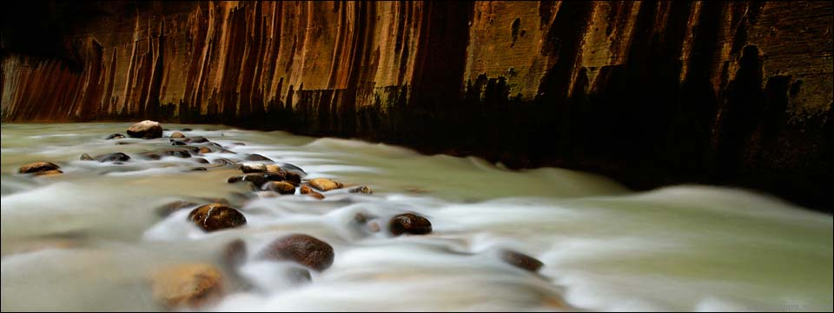

.*Source: Internet*

**A THOUGHT FOR TODAY:**

**'We cannot know someone only by following the events they have lived,**

**but by understanding how they lived them and**

**the wisdom they gained from these experiences.**



**May the good times and treasures of the present become**

**the golden memories of tomorrow.**

**Wish you all lots of love, joy and happiness.**

**MERRY CHRISTMAS**



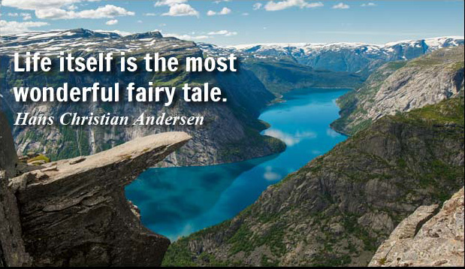

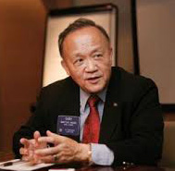

I can think of no better lessons to teach our families than the lessons of Rotary service.

**RI President GARY C.K. HUANG**

Please send information on club activities, progress reviews on service projects, relevant photos etc to:

BC Editor: RR Shrestha email: rryesrr@gmail.com

## 19 December 2014 The Weekly Bulletin of Rotary Club of Kathmandu Mid-Town bc-24/12.014

*******************************